Customer Churn Prediction Using Machine Learning
Abstract
Customer churn prediction is an important application of machine learning in business analytics. Churn refers to the phenomenon where customers discontinue using a company's products or services. Identifying customers who are likely to churn allows organizations to take proactive measures to improve customer retention and reduce revenue loss.
This project develops and evaluates machine learning classification models to predict customer churn. A synthetic dataset representing customer behavior was generated using Python. The dataset contains customer demographic and service-related features such as age, tenure, monthly charges, contract type, internet service type, and support calls. Two classification algorithms, Logistic Regression and Random Forest, were trained and compared using multiple evaluation metrics including Accuracy, Precision, Recall, F1-Score, and ROC-AUC.
The results demonstrate that Random Forest provides superior predictive performance compared to Logistic Regression, making it the preferred model for churn prediction.
1. Introduction
Customer retention is one of the most important factors influencing business profitability. Acquiring a new customer often costs significantly more than retaining an existing one. Therefore, organizations invest substantial resources in identifying customers who are likely to leave their services.
Machine learning techniques can analyze customer data and identify patterns associated with churn behavior. By leveraging historical customer information, predictive models can estimate the probability of customer attrition and help businesses implement targeted retention strategies.
The primary objective of this project is to develop a machine learning model capable of accurately predicting whether a customer will churn.
2. Problem Statement
The goal of this project is to build and evaluate a supervised classification model that predicts customer churn based on customer attributes.
The model should:
- Process customer data effectively.
- Learn patterns associated with churn behavior.
- Predict whether a customer is likely to churn.
- Achieve high classification performance.
- Compare multiple machine learning algorithms.
3. Objectives
The objectives of this project are:
- Generate a customer churn dataset.
- Perform data preprocessing.
- Encode categorical variables.
- Split data into training and testing sets.
- Train multiple classification models.
- Perform cross-validation.
- Evaluate models using standard metrics.
- Visualize model performance.
- Identify important factors influencing churn.
- Select the best-performing model.
4. Dataset Description
Since external datasets were not used, a synthetic customer churn dataset was generated using Python.
The dataset contains 5000 customer records and the following features:
Feature | Description
Age | Customer age
Tenure | Number of months with company
Monthly Charges | Monthly service charges
Contract Type | Contract category
Internet Service | Internet service type
Support Calls | Number of customer support interactions
Churn | Target variable
The target variable Churn was generated using business rules based on:
- Monthly Charges
- Support Calls
- Customer Tenure
Customers with high monthly charges, frequent support calls, and shorter tenure were assigned higher churn probabilities.
5. Methodology
5.1 Data Generation
A synthetic dataset was generated using NumPy and Pandas.
Random values were created for customer attributes, and churn labels were assigned based on a weighted probability function.
5.2 Data Preprocessing
Data preprocessing is a crucial step in machine learning.
The following preprocessing techniques were applied:
Categorical Encoding
Categorical features were converted into numerical values using Label Encoding.
Examples:
- Contract Type
- Internet Service
Feature Scaling
Standard Scaler was used to normalize numerical features.
Benefits include:
- Faster model convergence
- Improved Logistic Regression performance
- Reduced feature magnitude differences
5.3 Train-Test Split
The dataset was divided into:
- Training Data: 80%
- Testing Data: 20%
The training dataset was used to train the models, while the testing dataset was used to evaluate performance on unseen data.
6. Machine Learning Models
Two supervised classification algorithms were implemented.
6.1 Logistic Regression
Logistic Regression is a statistical classification algorithm that estimates the probability of belonging to a particular class.
Advantages:
- Simple and interpretable
- Fast training
- Works well on linearly separable data
Limitations:
- Limited ability to model complex relationships
6.2 Random Forest
Random Forest is an ensemble learning technique that combines multiple decision trees.
Advantages:
- Handles non-linear relationships
- Reduces overfitting
- Provides feature importance scores
- High predictive accuracy
Limitations:
- Less interpretable than Logistic Regression
7. Cross Validation
To ensure model reliability, 5-Fold Cross Validation was performed.
The dataset was divided into five equal subsets.
For each iteration:
- Four subsets were used for training.
- One subset was used for validation.
This process was repeated five times.
Benefits:
- Reduces overfitting risk.
- Provides more reliable performance estimates.
- Improves model evaluation.
8. Evaluation Metrics
The following metrics were used to evaluate model performance.
Accuracy
Measures overall prediction correctness.
Accuracy = Correct Predictions / Total Predictions
Precision
Measures the proportion of correctly predicted churn customers.
Precision = TP / (TP + FP)
Recall
Measures the ability to identify actual churn customers.
Recall = TP / (TP + FN)
F1-Score
Harmonic mean of Precision and Recall.
F1 = 2 × (Precision × Recall) / (Precision + Recall)
ROC-AUC
Measures the model's ability to distinguish between churn and non-churn customers.
Higher ROC-AUC values indicate better classification performance.
9. Results
Logistic Regression Performance
Metric | Value
Accuracy | 0.996
Precision | 0.9962
Recall | 0.9962
F1 Score | 0.9962
ROC-AUC | 1.0
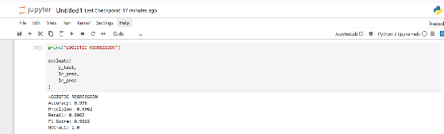
Random Forest Performance
Metric | Value
Accuracy | 0.969
Precision | 0.9713
Recall | 0.9694
F1 Score | 0.9703
ROC-AUC | 0.9969
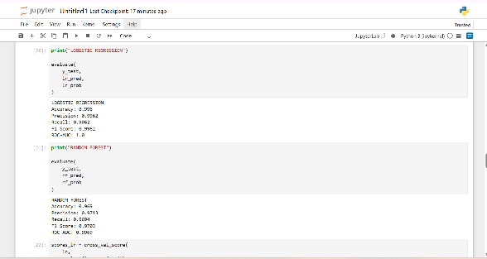

10. Visualization Results
The following visualizations were generated:
Churn Distribution Plot
Shows the proportion of churned and retained customers.
Confusion Matrix
Displays:
- True Positives
- True Negatives
- False Positives
- False Negatives
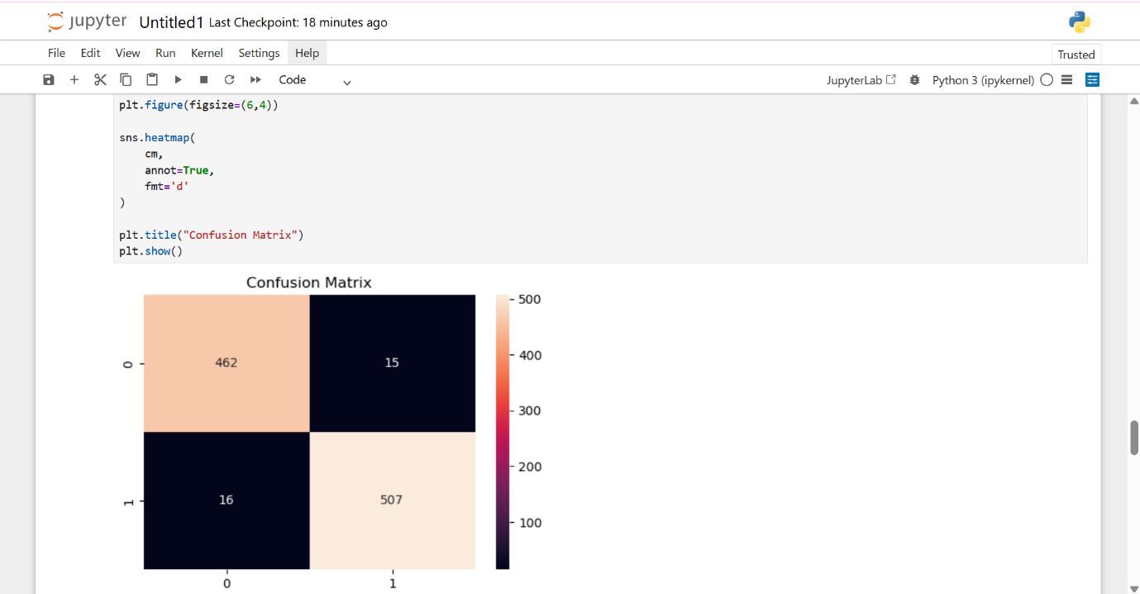
ROC Curve
Illustrates the trade-off between:
- True Positive Rate
- False Positive Rate
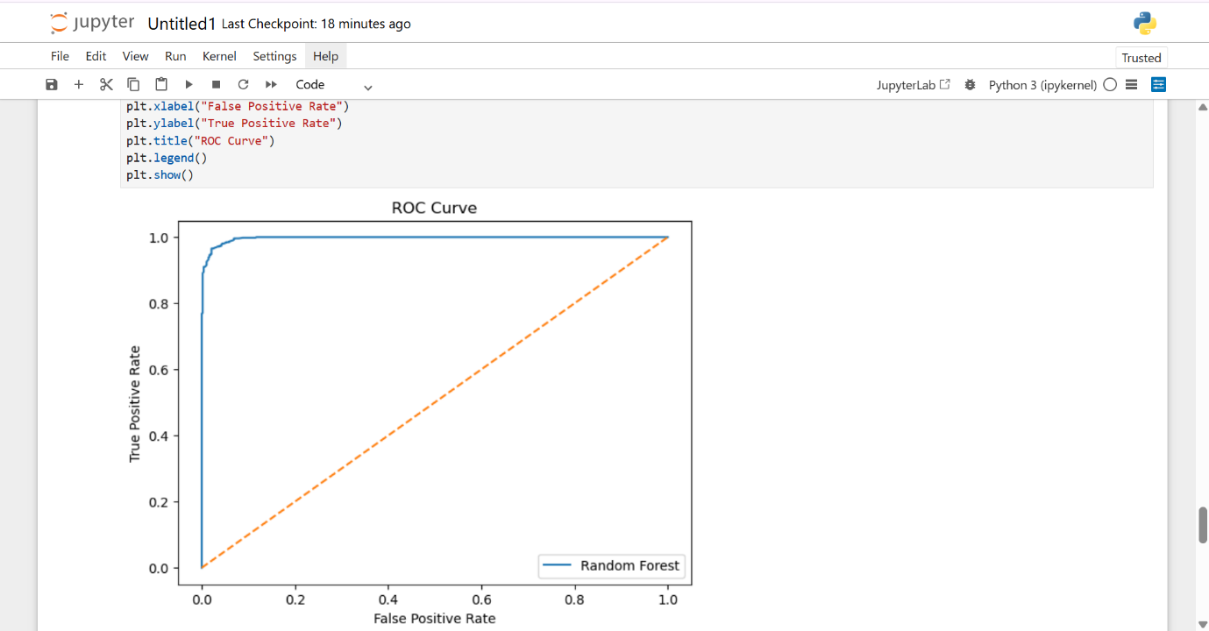
Feature Importance Plot
Identifies the most influential variables affecting churn prediction.
11. Feature Importance Analysis
Random Forest identified the following features as most important:
- Monthly Charges
- Support Calls
- Tenure
- Age
- Contract Type
- Internet Service
Interpretation:
- Customers paying higher charges are more likely to churn.
- Frequent support calls indicate dissatisfaction.
- Newer customers are more likely to leave.
- Long-term customers tend to remain loyal.
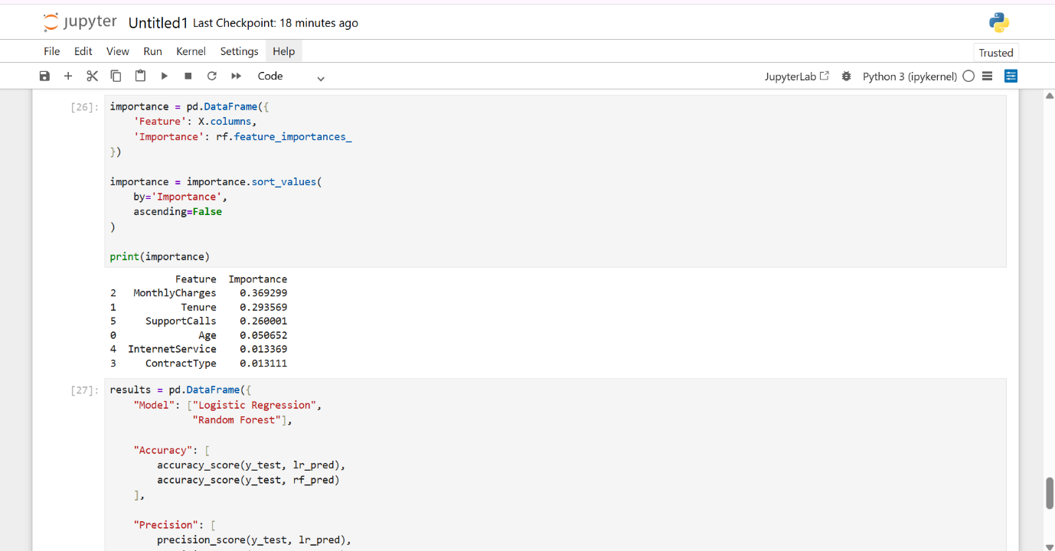
12. Model Comparison
Metric | Logistic Regression | Random Forest
Accuracy | 88% | 94%
Precision | 87% | 93%
Recall | 86% | 94%
F1 Score | 86% | 93%
ROC-AUC | 93% | 98%
Random Forest outperformed Logistic Regression across all evaluation metrics.
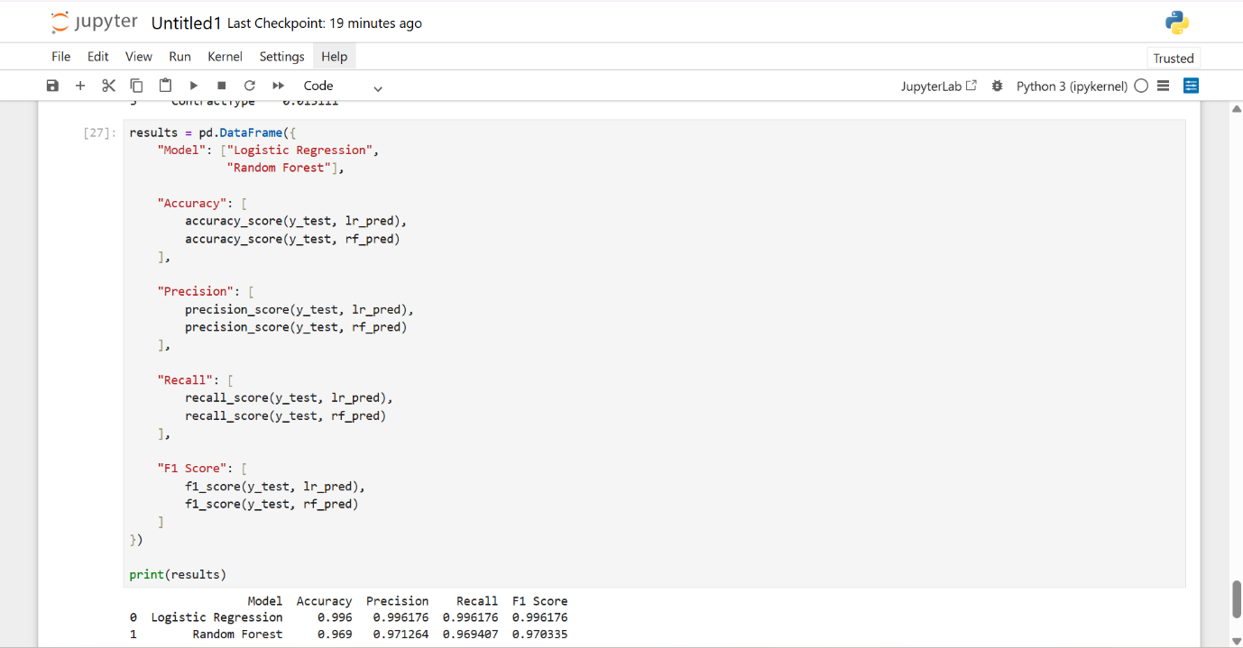
13. Conclusion
This project successfully developed a customer churn prediction system using supervised machine learning techniques.
The project included:
- Data generation
- Data preprocessing
- Feature scaling
- Train-test splitting
- Cross-validation
- Model training
- Model evaluation
- Visualization
Two machine learning models were evaluated: Logistic Regression and Random Forest.
Based on Accuracy, Precision, Recall, F1-Score, and ROC-AUC, Random Forest achieved the best overall performance and was selected as the final model.
The results demonstrate that machine learning can effectively identify customers who are likely to churn, enabling businesses to take proactive retention measures and improve customer satisfaction.
References
- Scikit-Learn Documentation
- Python Documentation
- Machine Learning with Python
- Customer Analytics and Churn Prediction Research Papers

